python 多进程

环境：
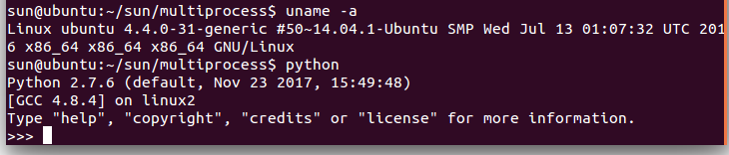

testmultiprocess01
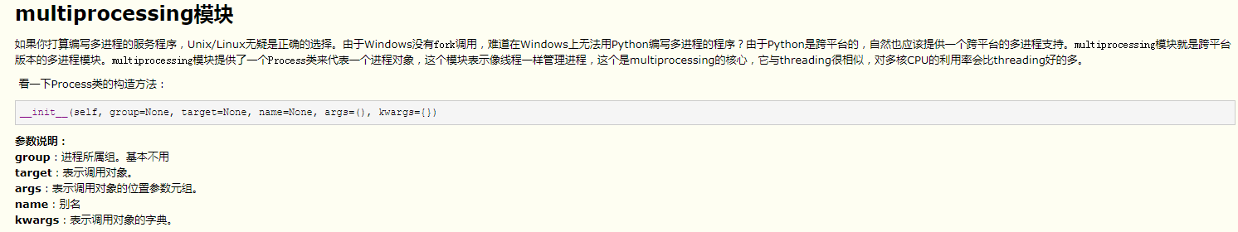
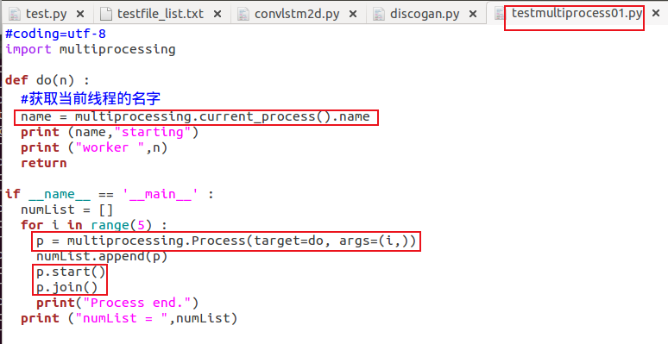
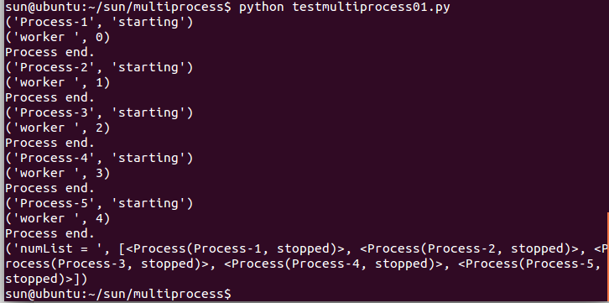
testmultiprocess02
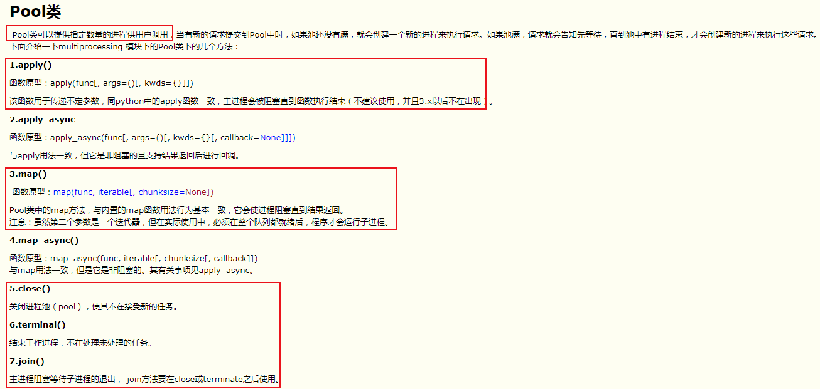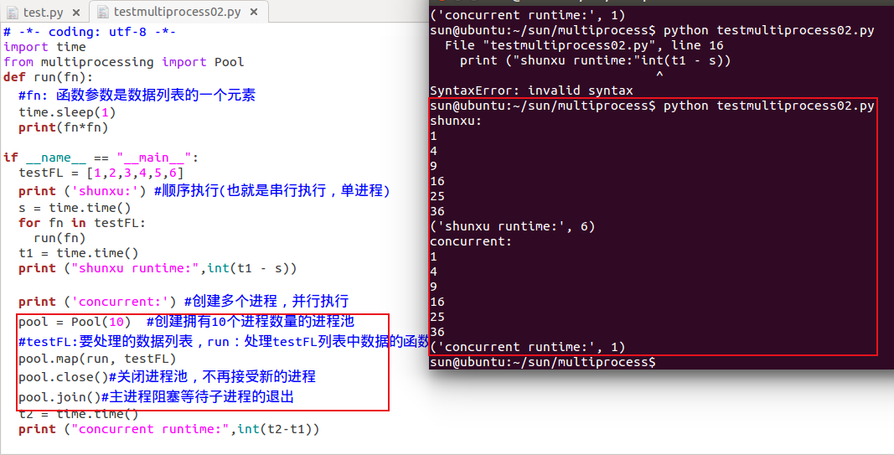

testmultiprocess03
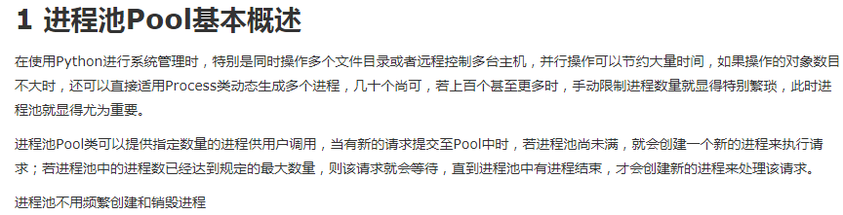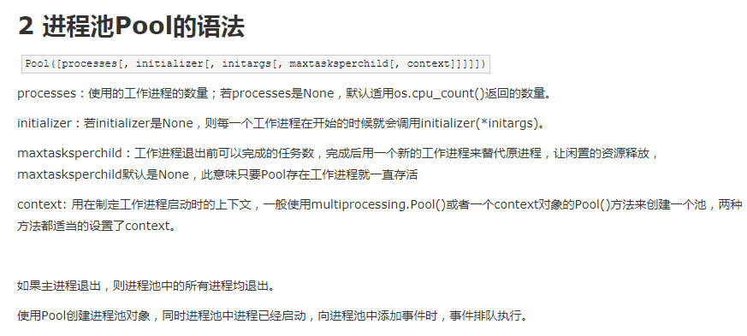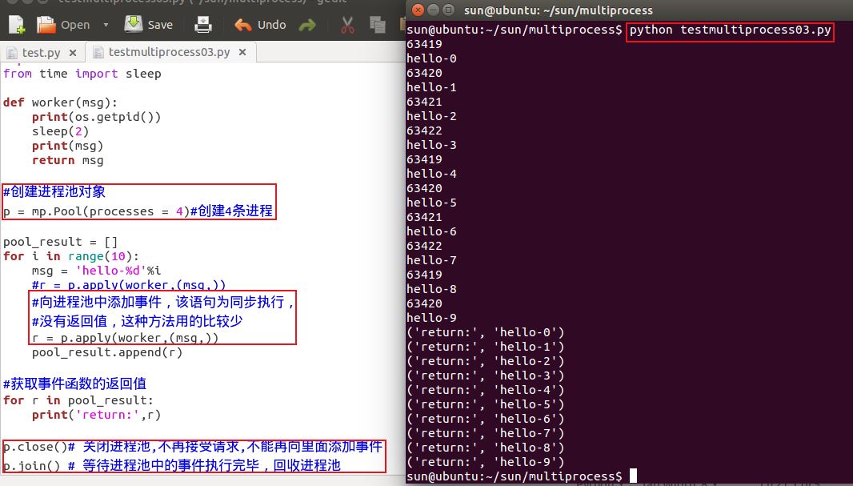
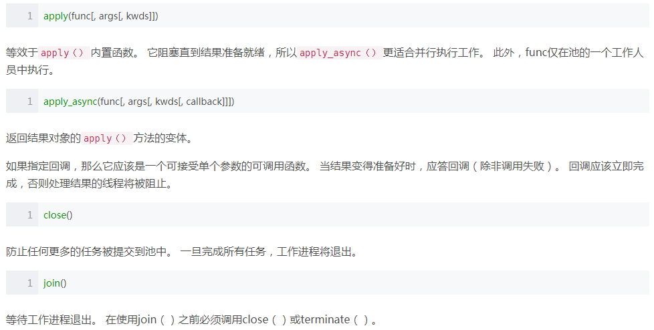

testmultiprocess04
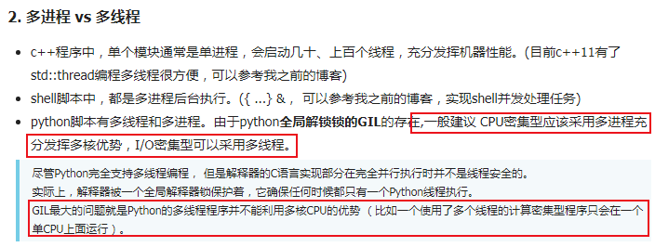
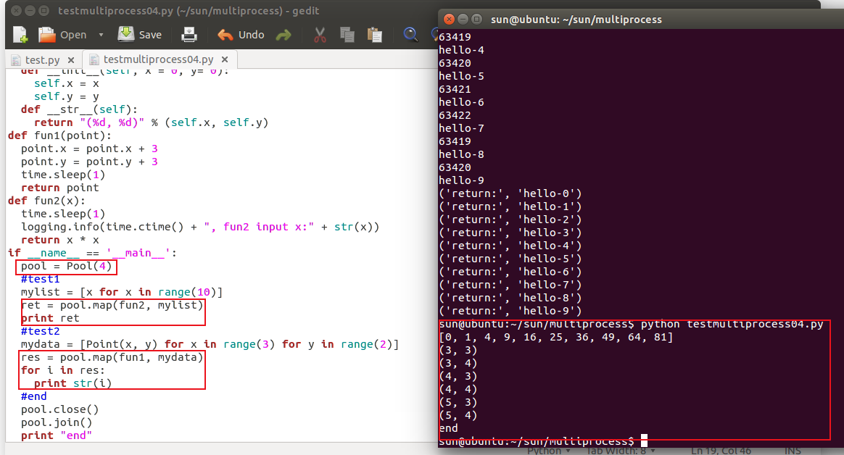

testmultiprocess05
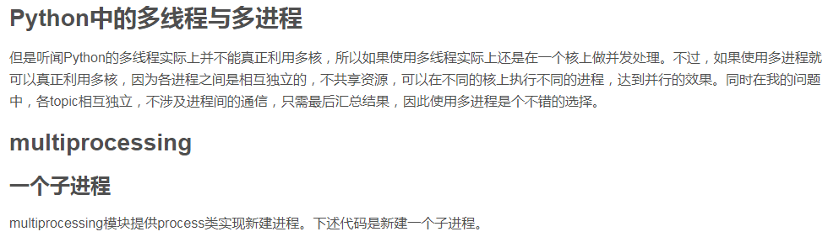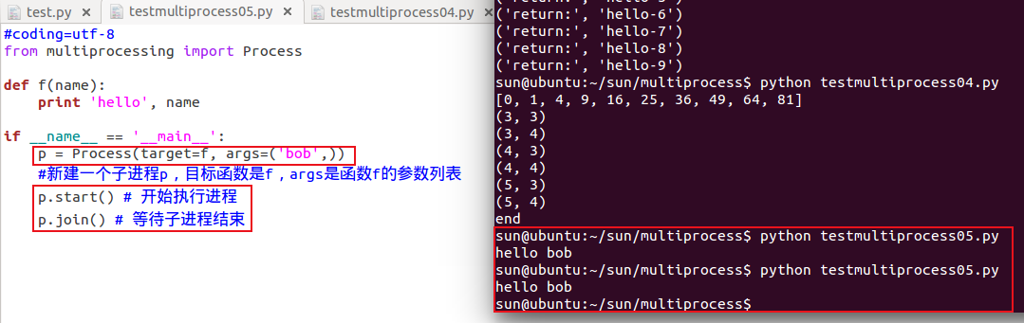

参考：

https://www.cnblogs.com/freeman818/p/7154089.html
https://www.cnblogs.com/gengyi/p/8620853.html
https://www.jb51.net/article/147039.htm
https://blog.csdn.net/ztf312/article/details/80337255

